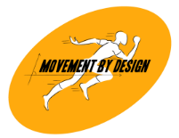
NUTRITION COUNSELLING FOLLOW UP SHEET
Date: ____/____/________
Patient Name: __________________________________________________ Patient ID: _______________
Age: _________ Sex: __________ Dominance: __________ Contact no.: __________________________
Occupation: ___________________ Sport: _______________________________________________________
Address: _____________________________________ Attending Nutritionist: __________________________

Body Wt.: _______ kg | Height: _______ cm | BMI: _______ kg/cm² | BP: _____/____ mmHg

Comorbidities: DM HTN CAD PCOS Thyroid issues ( / ) Other: _____________________
C/O: __________________________________________________________________________________________
Primary Goal: __________________________________________________________________________________

No. | Date | Nutrition Counselling Session | Remark | Sign
Patient Name: ______________________________ Goal: ____________________________________________

No. | Date | Nutrition Counselling Session | Remark | Sign

